

**UNIVERSITY OF PETROLEUM AND ENERGY STUDIES**

**School of Computer** **Science**

**2020-21**

**GRAPHICS AND ANIMATION TOOLS LAB**

**Faculty: Dr. DURGANSH SHARMA**

**Assistant Professor**

**Department of Cybernetics.**

**School of Computer Science, UPES**

**Submitted By:**

**Name- Garima Dhall**

**Roll no-R100217025**

**Batch-B1**

**Semester- 7**

**Course-B.tech. CSE-OSOS**

**Sap Id- 500062498**

**EXPERIMENT NO 4**

**Aim** :- Design your own animation using GIMP

**Objective** :- To Design your own animation using features of GIMP.

**STEPS TO MAKE ANIMATION :-**

1. Open GIMP workspace on your device and create a new template with demensions of your choice

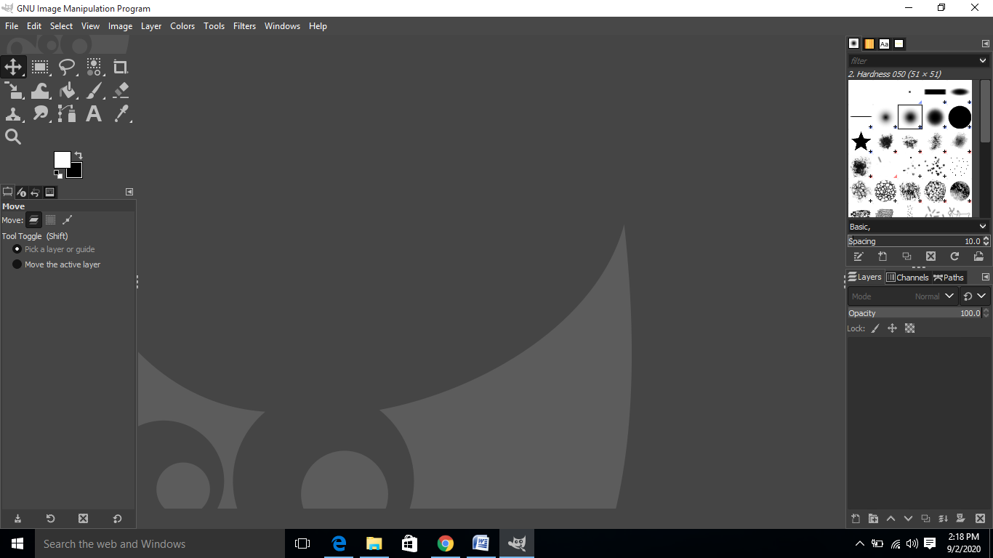

1. Then download the images of your own choice and open them in GIMP and start inserting into your template

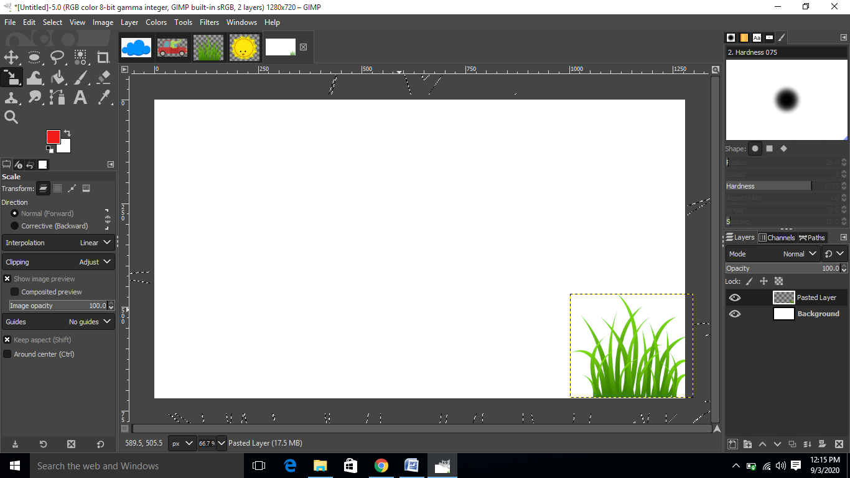

1. Starting inserting one image after the other and with adding the new image we have to create the floating layer into the new layer and like this we need to create a scenery view

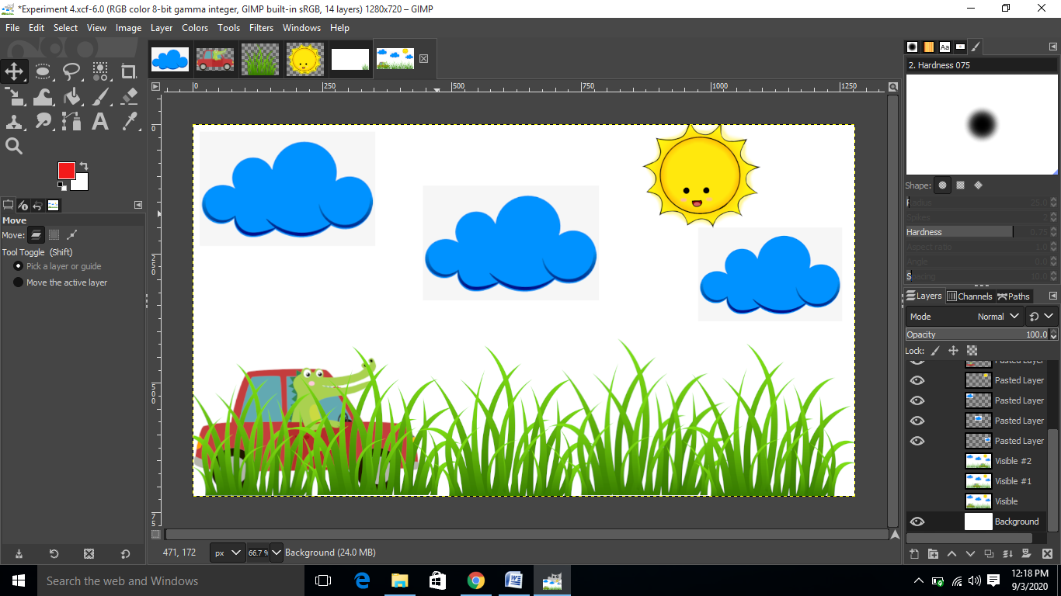

1. After inserting all the images into the view you want to show then right click on the background layer and then click on new from visible and starting positioning the car into different positions

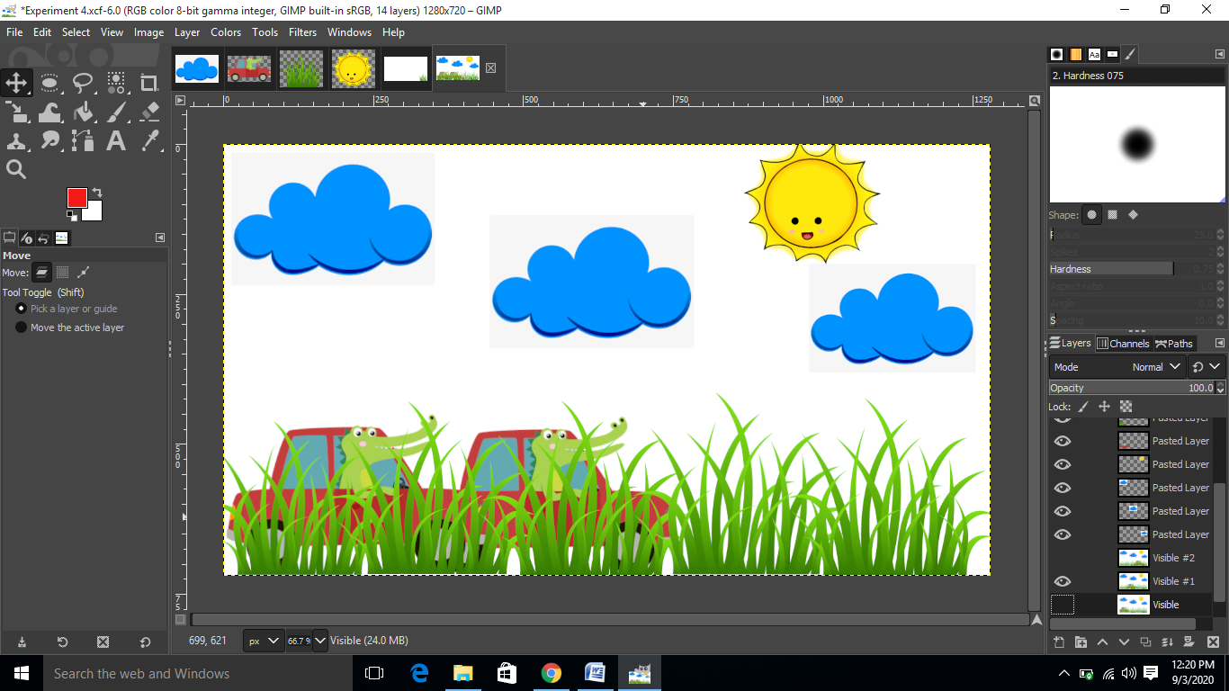

1. Then after setting the position hide the visibility of the visible layer

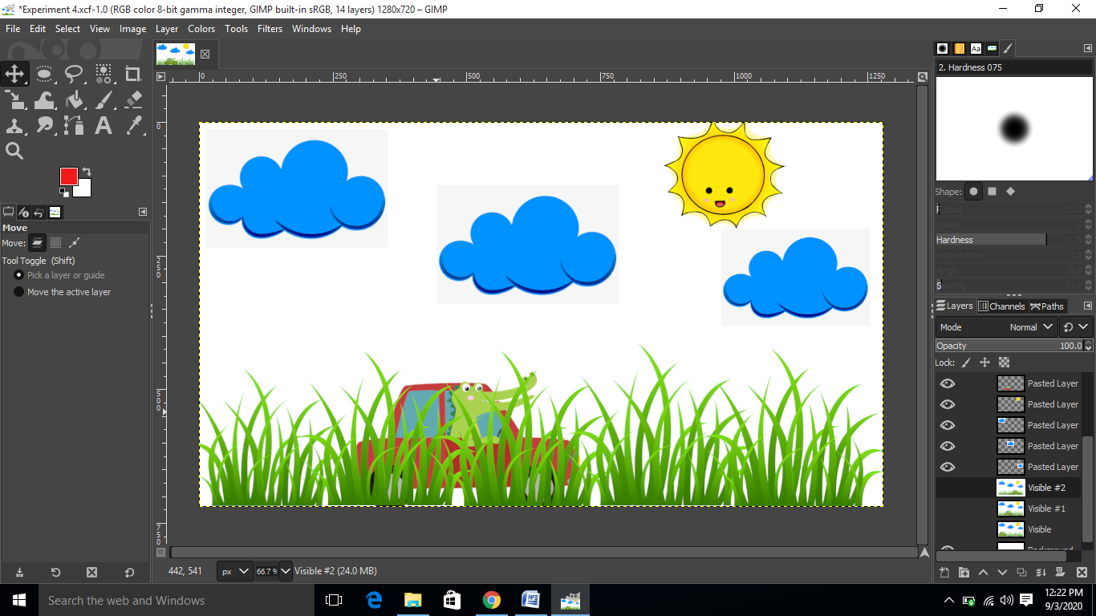

1. After this we have to repeat step 4 and 5 and once we get the last frame we only need to go to filters and then click on animations and then click on playback

